**Problem 1:** People who deal with historical dates use a number called the Julian day to calculate the number of days between two events. The Julian day is the number of days that have elapsed since January 1, 4713 B.C. For example, the Julian day for October 16, 1956, is 2435763.

There are formulas for computing the Julian day from a given date, and vice versa. One very simple formula computes the day of the week from a given Julian day:

Day of the week = (Julian day + 1) % 7 where % is the Java modulus operator. This formula gives a result of 0 for Sunday, 1 for Monday, and so on, up to 6 for Saturday. For Julian day 2435763, the result is 2 (Tuesday). Your job is to write a C++ program that requests and inputs a Julian day, computes the day of the week using the formula, and then displays the name of the day that corresponds to that number.

Your output might look like this:

Enter a Julian day number and press Enter.

2451545

Julian day number 2451545 is a Saturday.

Enter a Julian day number and press Enter.

2451547

Julian day number 2451547 is a Monday.

**Problem 2:** Write a program that reads a customer’s account number (int type), account type (char; s for savings, c for checking), minimum balance that the account should maintain, and current balance. The program should then output the account number, account type, current balance, and an appropriate message. Test your program by running it five times, using the following data:

46728 S 1000 2700

87324 C 1500 7689

79873 S 1000 800

89832 C 2000 3000

98322 C 1000 750

**Problem 3:** Write a C++ program that determines the median of three input numbers. The median is the middle number when the three numbers are arranged in order. However, the user can input the values in any order, so your program must determine which value is between the other two. For example, if the user enters:

41.52; 27.18; 96.03

Then the program would output:

The median of 41.52, 27.18 and 96.03 is 41.52

Once you have the three-number case working, extend the program to handle five numbers.

Note: Be sure to use proper formatting and appropriate comments is your code.

**Problem 4:** Write C++ that plays the game of “Rock, paper, scissors.” In this game, two players simultaneously say (or display a hand symbol representing) either “rock,” “paper,” or “scissors.” The winner is the one whose choice dominates the other. The rules are: paper dominates (wraps) rock, rock dominates (breaks) scissors, and scissors dominate (cut) paper. Declares and initializes First player and second player variables at the start).

You can use 1=rock, 2=paper,3=scissors

**Examples:**

First player = 1, second player = 1

Sample Output: Draw

First player = 1, second player = 2

Sample Output: 2nd player wins

**Problem 5:**

Keep inputting two numbers from the user. You have to stop when the sum of the two numbers is odd; otherwise input the two numbers again. At the end you have to output the product of all the numbers input by the user.

**Problem 6:**

Write a C++ program that takes 2 integers (i) a starting number and (ii) the number of elements in last row. Then print then prints the data in form a lower triangular matrix. For example, if the starting number is 10 and the number of elements in last row is 3, then output would be

10

11  12

13 14 15

Note: You have to do it using a single while loop.

**Problem 7:**

Write a program to calculate the place value of digit in an integer.

For example, if the user inputs an integer *56918* and you want to determine the place value of *6*, the output would be “Thousands”. You can include a check for whether that specific digit is present or not.Your program should work for a maximum place value of “millions”.

*\*Units; tens; hundreds; thousands; ten thousands; hundred thousands; millions.*

**Problem 8:**

Write a program that prints a triangular pattern. The program asks the user to enter the height of the triangle and the character to use. For example:

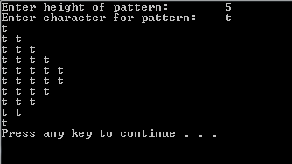

**Problem 9:**

π can be calculated using the following infinite series:

$$π=4- \frac{4}{3}+ \frac{4}{5}- \frac{4}{7}+ \frac{4}{9}- \frac{4}{11}+ …$$

Write a code that prints the value of π after the first 100 terms, 200 terms and 300 terms (in the same code).

**Problem 10:**

Write a program that takes in a fraction and then displays that fraction in the reduced form. For example:



**Problem 11:**

Write a program that calculates:

$f\left(x\right)= f1(x)+ f2(x)$,

where $f1\left(x\right)=\sqrt{15 * {\left(x – 2\right)}^{n}}$ and $f2\left(x\right)= \log_{10}(\sqrt[3]{3x(n+1})$.

The user will enter the value of x and n (where n is the number of terms to be calculated, starting from $n = 0$). The output should be formatted as below:

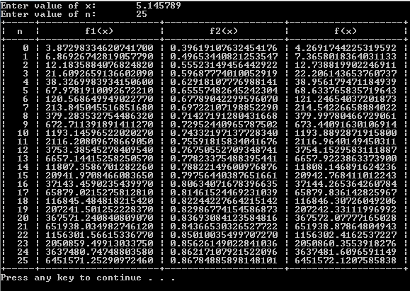

( HINT: Look up functions available under iomanip and iostream libraries)

**Problem 12:**

Write a program that prints a triangular pattern. The program asks the user for the height of the triangle and whether to print the triangle in ascending or descending order. The user must enter either 0 or a (for ascending pattern) and either 1 or d (for descending pattern). If the user enters an invalid option, the program must display an error and ask for input again. Program should terminate if the user enters the character q. For example:

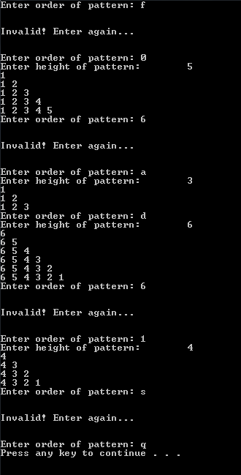

**Problem 13:**

Suppose that the first number of a sequence is x, in which x is an integer. Define $a_{0}$ = x; $a_{n+1}$ = $a_{n}$/2 if $a_{n}$ is even; $a_{n+1}$ = 3 x $a_{n}$ + 1 if $a_{n}$ is odd. Then, there exists an integer k such that $a_{k}$ = 1. Write a program that prompts the user to input the value of x. The program output the integer k such that $a_{0}$ = 1 and the numbers, $a_{0}, a_{1},a_{2}, . . . , a_{k}$. (For example, if x = 75, then k = 14, and the numbers, $a_{0}, a_{1},a_{2}, . . . , a_{14}$, respectively, are 75, 226, 113, 340, 170, 85, 256, 128, 64, 32, 16, 8, 4, 2, 1.) Test your program for the following values of x: 75, 111, 678, 732, 873, 2048, and 65535.

**Problem 14:**

Write a program that asks for the value of N i.e. the number of students for which the data will be entered, and all of the marks obtained in the courses for those students. The output would be the total marks obtained and the grades assigned to those students in each course.

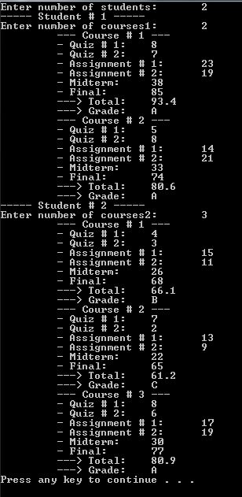

**Problem 15:** Every single part of this question has something to do with prime numbers.

1. Write a C++ program that takes any 2-digit number and determines whether that number is a prime or not.
2. Now consider your roll number, take the last four digits of your roll number and calculate ${Roll_no}^{0.8}$, e.g. if your roll-no is L14-5134, you would calculate ${5134}^{0.8}$. Determine the prime number before and after the number ${Roll_no}^{0.8}$.

You may call the former as prime_former and the latter as prime_latter.

A number, limit, is equal to prime_former if | – prime_former| is greater than | – prime_latter|, else limit is equal to prime_latter; where |x| represents the magnitude of the quantity x.

You have to calculate and display all the prime numbers between the 2-digit number from part (I) and the number limit.

1. Modify your program from part (II), such that it only displays all the prime numbers that have the digit 7 in them.

**Problem 16:** Write a C++ program that uses nested loops to output the following pattern. The height of the pattern is to be input by the user and should not be greater than 9.

1 2 3 4 5 6 7 6 5 4 3 2 1

1 2 3 4 5 6 6 5 4 3 2 1

1 2 3 4 5 5 4 3 2 1

1 2 3 4 4 3 2 1

1 2 3 3 2 1

1 2 2 1

1 1